Pakin Panwattanakul 6580043

1. Edit “01 A First Document.tex” as follows and report your results (screen captures) with your code.
   1. Change the 8tle of the document to be your own senior project title
   2. Enter your name as a first author and other project member(s) if available.



| \documentclass[a4paper]{article} *%Always requireed* *%========================================================================* *% preamble to declare kackges used in the document* *%========================================================================* *%Packages that will be used*  *%To use a block comment in a document* \usepackage{comment}  \begin{comment}  Test a block comment  \end{comment} *%------------------------------------------------------------------------* \usepackage{fontspec} *%Either Xelatex or Lualatex is required as a default complier* *%To learn more about "fontspec" package: https://ctan.org/pkg/fontspec?lang=en*  *%========================================================================* *%To declare a document title and an author(s)*  \title{Design and Evaluation of a Cryptography Accelerator on FPGA} *%\author{Firstname Lastname}*  \author{  Nitchayanin, Thamkunanon\\  \texttt{nitchayanin.tha@student.mahidol.edu}   \and  Panupong, Sangaphunchai\\  \texttt{panupong.sap@student.mahidol.edu}  \and  Pakin, Panawattanakul\\  \texttt{pakin.pan@student.mahidol.edu} } *%document* \begin{document}  \maketitle  *%Put your text in a body of your document here...*   Hello World   \end{document} *%=======================================================================* |
| --- |

1. Edit **“Q2 Formatting and Lists.tex”** by formatting text as shown below.

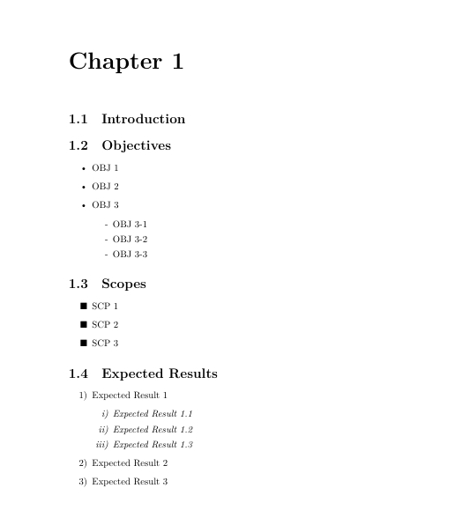

| \maketitle  *%Put your text in a body of your document here...*   \setcounter{chapter}{1}  \chapter*{Chapter 1}    \section{Introduction}    \section{Objectives}  \begin{itemize}  \item OBJ 1  \item OBJ 2  \item OBJ 3  \begin{itemize}  \item [-] OBJ 3-1  \item [-] OBJ 3-2  \item [-] OBJ 3-3  \end{itemize}    \end{itemize}   \section{Scopes}  \begin{itemize}  \item [$\blacksquare$] SCP 1  \item [$\blacksquare$] SCP 2  \item [$\blacksquare$] SCP 3  \end{itemize}    \section{Expected Results}  \begin{enumerate} [label=\arabic*)]  \item Expected Result 1  \begin{enumerate} [label=\textit{\roman*)}]  \item \textit{Expected Result 1.1}  \item \textit{Expected Result 1.2}  \item \textit{Expected Result 1.3}  \end{enumerate}  \item Expected Result 2  \item Expected Result 3  \end{enumerate} |
| --- |

3. Add a new sec on “1.5 Timeline” into Chapter 1 from previous ques on and insert the “timeline.jpg” as a picture. Report your results and coding.

Note : using my group’s timeline for bonus question

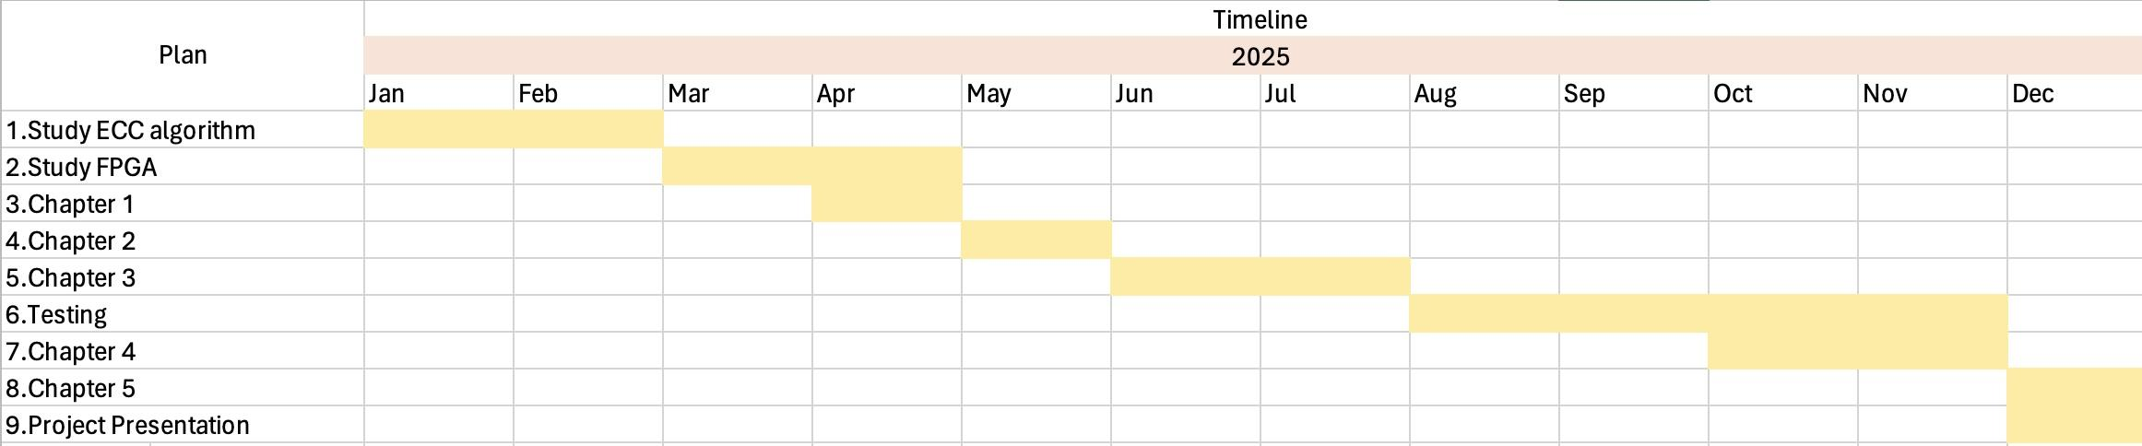

| \newpage  \section{Timeline}  \begin{figure}[!h]  \noindent\Centering  \includegraphics[width=1\textwidth]{MyTimeline}  \caption{Senior Project timeline}  \label{fig:Project timeline}  \end{figure} |
| --- |

4. Add a new section on “1.6 Subplot” Change the code from the previous question on to add a subplot of 4 figures including A.jpg, B.jpg, C.jpg, and D.jpg as shown below. Report your results and code.

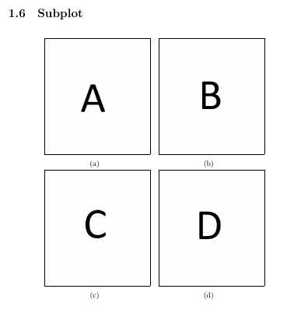

| \section{Subplot}  \begin{figure}[h!]  \centering  \begin{subfigure}[b]{0.35\linewidth}  \Centering  \fbox{\includegraphics[width=\linewidth]{A}}  \caption{}  \end{subfigure}  \hspace{1em} *% Space between image*   \begin{subfigure}[b]{0.35\linewidth}  \fbox{\includegraphics[width=\linewidth]{B}}  \caption{}  \end{subfigure}  \hspace{1em} *% Space between image*   \begin{subfigure}[b]{0.35\linewidth}  \fbox{\includegraphics[width=\linewidth]{C}}  \caption{}  \end{subfigure}  \hspace{1em} *% Space between image*   \begin{subfigure}[b]{0.35\linewidth}  \fbox{\includegraphics[width=\linewidth]{D}}  \caption{}  \end{subfigure}   \end{figure} |
| --- |